A couple of things to note before go through the documents
1. This is only reviewing Bryte AI replies. I still need to go through the summary AI generated yet.
2. The current documentation here is for a Voya and UKG retirement plan. I need to review the other UKG retirement video we uploaded to check if the conversation patterns are consistent across both systems.
Here is the link to the video, if you need access, please ping Nitisha
RetirementPlanAgentRecording.webm
Principle | Score
Clarity | 1.5
Brevity | 2.5
Context Awareness | 0.5
Consistency | 1
Empathy & Tone | 2
Error Recovery | N/a
Turn-Taking & Flow | 1
Confirmation & Feedback | 2
Proactive Guidance | 0.5
Accessibility & Inclusivity | 1.5
Overall Average | 1.4/5
Most Critical Issues
- failure to extract and use document information (Context Awareness: 0.5)
- No guidance or explanations for technical options (Proactive Guidance: 0.5)
- Backwards question sequencing and poor flow (Consistency & Flow: 1.0)
- Pervasive use of unexplained technical jargon (Clarity & Accessibility: 1.5)

Principle: Context Awareness (Score: 0.5/5)

Issues Identified:
Issue – showing no awareness of context
Ask the same question again for employer instead of asking whether they follow the same configuration as the employee
• Creating unnecessary repetition - wasting the user's time
- Increasing user fatigue - adding more questions when you could intelligently apply existing information
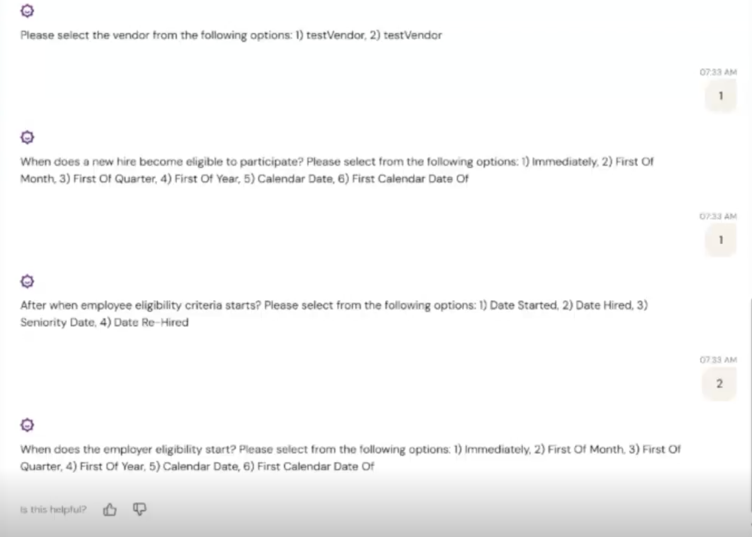
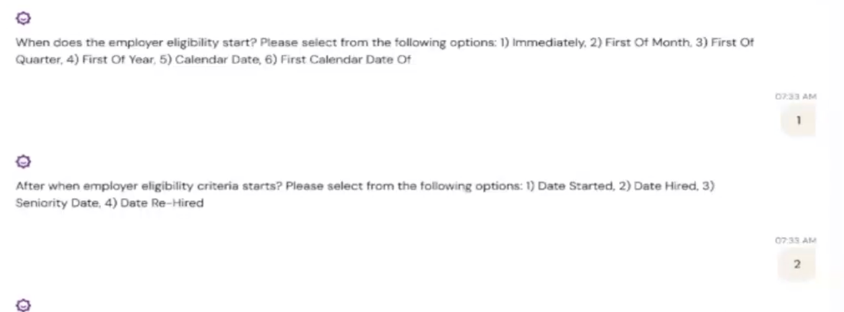
Issue - AI fails to extract information from uploaded documents:
- Asks for vendor name despite "Voya" being mentioned in the document
  - [Mahima: even though document suggest Voya as a vendor, prompt is instructed to choose only from the vendors configured in the system. The company which I am using does not have proper data setup to match the details with the document which will not be the case in prod]
KQ we need to update the prompt to map vendors that are not in our system, instead of asking
From Oct 13 demo
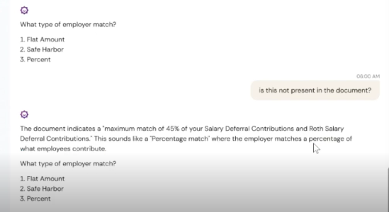
AI has already replied is “a percentage match”, indicating that it should know, it is a % match, so why is it not extracting the data instead of asking the user?
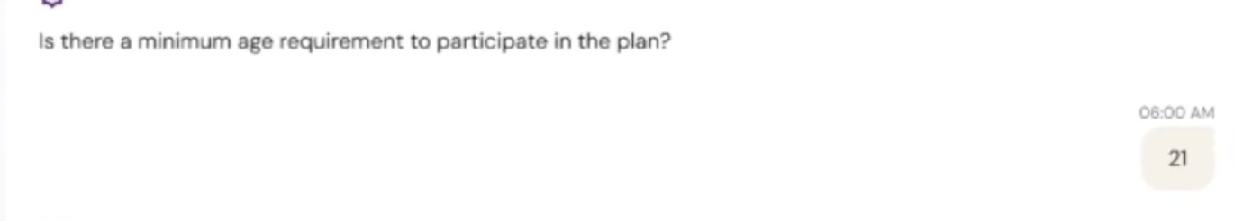
The document has the min age information, but the AI is not picking up

Principle: Clarity (Score: 1.5/5)
[Mahima: These are system configurations and as per the initial discussions with Nitisha we are suppose to show these details only for now.]
KQ: this is why we are not displaying the configuration page, confusing terminology used
Issue - Ambiguous questions or options
- "Seniority date”
ambiguous and can be open up to different interpretation.
=

- "System Rules/Yes/No" options:
No explanation of when to use each option. "System Rules" is unclear with no definition
provided.
Again pulling from the existing system configuration doesn’t work, In the system configuration, this is badly phrase.

Nitisha, Mahima, What we are asking the user is
This Is box 13 in W2 look likes
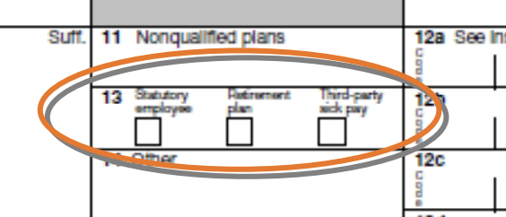
Box 13 on a W-2 tells the IRS: "This employee was eligible to participate in a retirement plan this year."
It's important because it affects whether the employee can deduct IRA contributions on their taxes.

The correct way to explain to the user

First choice (system rules): The system will check the box ONLY if the employee actually used the retirement plan - meaning they either:
- Put their own money into the plan (deferrals), OR
- Received employer contributions (like a match or profit sharing)

Second choice: Always Check It(yes)

Check Box 13 for everyone in this plan, no matter what - even if they didn't contribute a penny.

Example: Employee never signed up for the 401(k), but you still check the box because they were eligible.

Third choice: Never Check It (No)

Never check Box 13 for anyone in this plan.
Example: This might be used for certain non-qualified plans that don't count as "retirement plans" for IRS purposes.
.

- "W2 pension box type":
the terminology use in W2 form is retirement plan not ”pension type”. In US 401k plans are commonly referred to retirement plan and pension. Potentially confusing to the user

It should be : When should Box 13 'Retirement plan' be checked on W-2 forms?


- Option 2-6 are not clear:
First month/ quarter/ year…. of what?

In the UI, when the user selects option 2-6, the text “following waiting period is displayed, but here it didn’t (Please see subsequent screenshots)
[Mahima: These are system configurations and as per the initial discussions with Nitisha we are suppose to show these details only for now.]
Nitisha, just by pulling system configuration is not working, we are missing information

Issue - Using terminology that users will not understand:
- "Primary deduction type”
Actual meaning: If user has more than 1 retirement plan, which one should be the primary plan
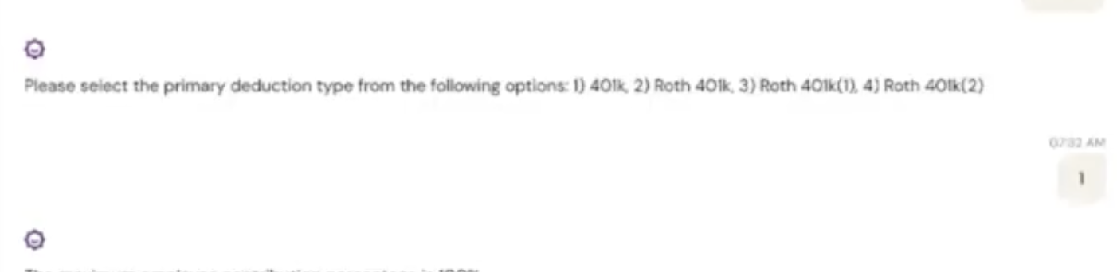
- “Additional deduction level"
Actual meaning: Whether the user has another retirement policy to include in the retirement plan
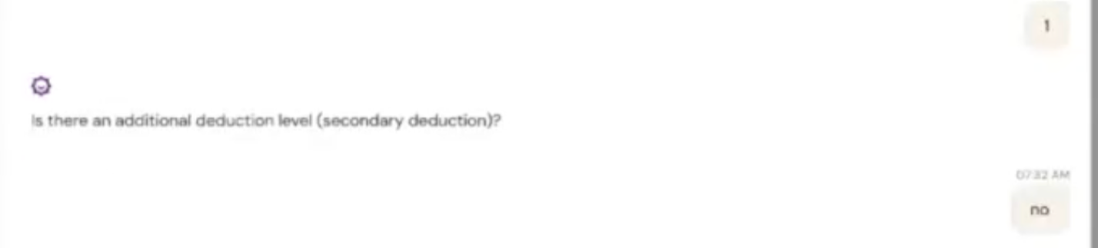
- “primary deduction type (rollup deduction) ”
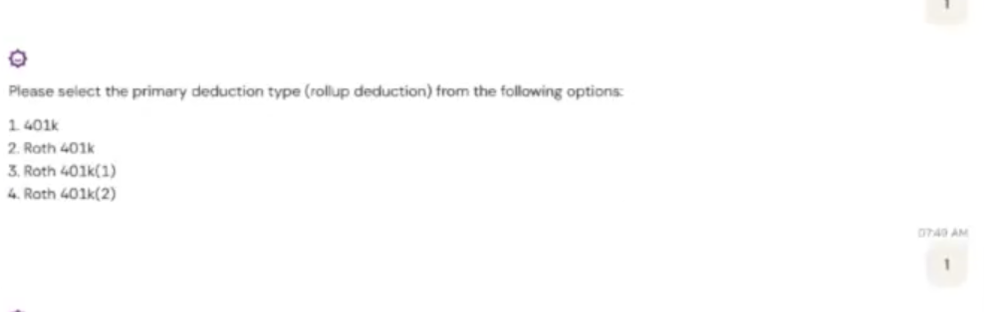

- “additional deduction level (secondary deduction)”
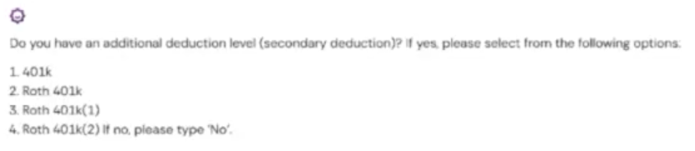

Principle: Turn-Taking & Flow (Score: 1.0/5)

Issues Identified:
Issue : No Logical Grouping or Chunking
The conversation has no logical progression. It should go:
- Plan basics → 2. Eligibility → 3. Contributions → 4. Deductions → 5. Confirmation
Instead it goes:
- Some questions → 2. Random repeat questions → 3. More random questions → 4. Back to earlier questions
What's wrong:
- Mixes eligibility questions (age, service hours) with contribution questions (Roth, max amount)
- These are DIFFERENT TOPICS that should be in different sections
- Creates cognitive load - user has to mentally switch contexts rapidly
Why this matters
- Reduces cognitive load
- Makes the conversation feel organized and professional
- Easier for users to answer related questions in sequence
- Easier to review and verify answers by topic
Issue - Order of questions wrong:
- Asks "WHEN does eligibility begin" (Question 2) BEFORE asking "IS THERE a waiting period" (Question 3) - this is backwards
Correct order
Question 1: "Is employee eligibility criteria for this retirement plan
- supported based on the start date? (Yes/No)"
- Question 2: "Is there a waiting period for employee eligibility? (Yes/No)"
- ↓
- If YES → "How long is the waiting period?"
- If NO → "When does eligibility begin immediately?"
- Question 3: "When does a new hire become eligible to participate?"
- [Now this makes sense because we know if there's a waiting period]

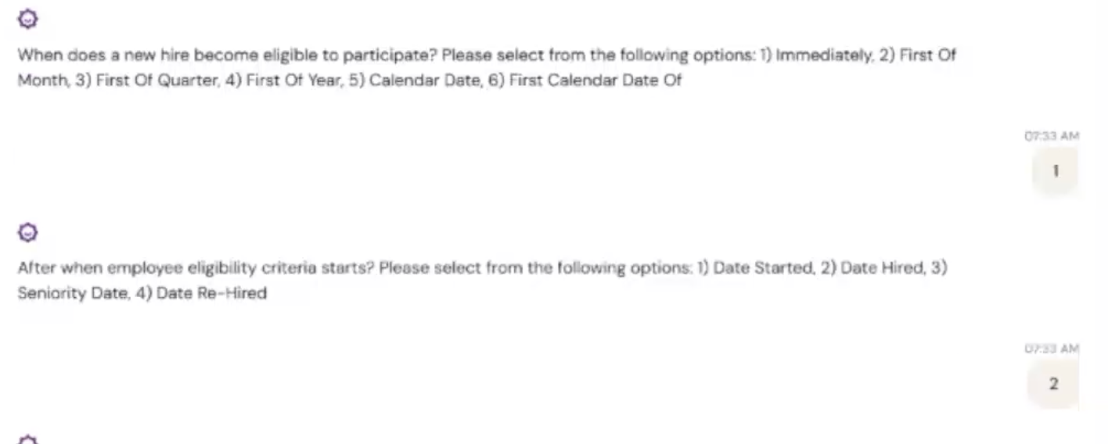
Issue - Context-setting questions in wrong position:
- Question about whether the user has another retirement policy appears in the middle of the conversation
- Should be asked at the start to establish scope and structure
- Forces users to mentally reorganize information
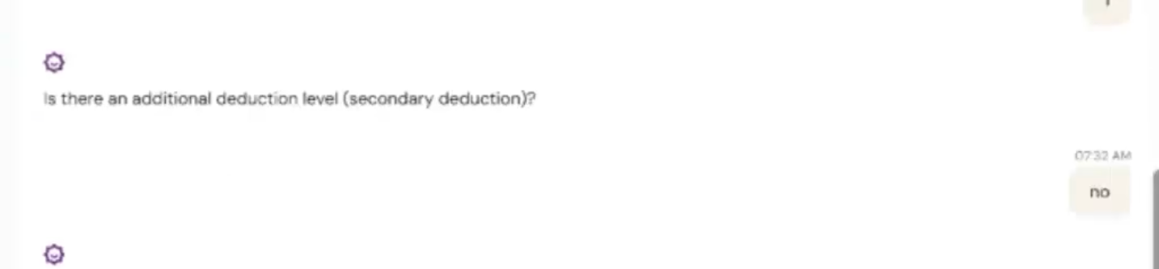

Issue - Questions preceded by unrelated information:
- Information about employee contribution limits appears before W-2 questions
- Breaks topical flow and creates confusion


Principle: Brevity (Score: 2.5/5)
[Mahima: Sometimes agent show random behavior and tag unrelated fields together. Grouping of fields is already done in the prompt but agent sometimes does not follow the instructions exactly and show random behavior
KQ: We need to update the prompt to refer to the JSON file I written for better grouping

Issues Identified:
Issue - Questions preceded by unrelated information:
- The statement "The maximum employee contribution percentage is 100%" (about employee contribution limits) appears above a question about W-2 tax form reporting
- These are unrelated topics, which confuses users about how to answer the question
- Adds unnecessary verbosity and cognitive load


Principle: Consistency (Score: 1.0/5)

Issues Identified:
[Mahima: We are advised not to hardcode these kinds of instructions and let agent decide what is the correct way to ask questions to the user and what are the best options for the response]
KQ: this is totally a misconception
Their advice assumes AI understands user needs—it doesn't. AI reflects what it's trained on, not our brand tone, compliance requirements, or user anxiety levels.
Three risks of AI-generated questions:
- If the AI constructs questions, we introduce variability. One user might get asked about '401k contribution limits' while another gets 'maximum allowable deferrals', same concept, different phrasing. Clear winner is “401K contribution limits”
- Compliance risk → retirement config is regulated; can't risk miscommunication and user provide wrong answer
we need precision, not creativity
What we actually need AI for:
- Long-tail edge cases ("We have profit-sharing that vests over 3 years...")
- Clarifying ambiguous answers
- Real-time validation against IRS limits

Issue - Mixing option types within single questions:



Principle: Empathy & Tone (Score: 2.0/5)

Issues Identified:
- Uses technical UKG terminology without considering user's knowledge level
- No explanations provided for complex options (System Rules/Yes/No)
- Doesn't acknowledge when users might be confused by terminology
- Lacks warmth or user-centered approach
- No attempt to make technical retirement plan concepts more accessible

Principle: Error Recovery (Score: N/A)

Issues Identified:
- No evidence of error handling scenarios in the documentation
- Cannot assess from provided examples

Principle: Confirmation & Feedback (Score: 2.0/5)

Issues Identified:
Issue 9 - Premature recommendations:
- Provides recommendations before all clarifying questions are asked
- Should confirm complete understanding before making suggestions
- No clear confirmation of extracted information from document before asking redundant questions

Principle: Proactive Guidance (Score: 0.5/5)

Issues Identified:
Issue 2 - No explanation of options:
- "System Rules/Yes/No" options provided with no guidance on when to use each
- Multiple date type options with no explanation of differences
- No indication of which options are most common or recommended
Issue 3 - Technical terminology without context:
- UKG-specific terms used without definitions or examples
- No proactive explanation of what "W2 pension box type" means in practical terms
Issue - Missing context for questions:
- Doesn't explain waiting period concept before asking questions about it
- No guidance on what "two separate aspects" are being configured
- Fails to provide framework for understanding questions

- 

Principle: Accessibility & Inclusivity (Score: 1.5/5)

Issues Identified:
Issue - Barriers from UKG terminology:
- Heavy use of UKG-specific terminology creates barriers for users unfamiliar with the system
- "Primary deduction type," "W2 pension box type," "additional deduction level" all assume technical knowledge
- No consideration for users without retirement plan administration expertise
Issue - Grammatical errors:
[Mahima: I’ve reframed the questions, and most of the grammatical issues have been addressed. Please feel free to point out anything I might have missed]
- Grammatically incorrect questions impact comprehension
- Reduces accessibility for all users, especially those with language barriers

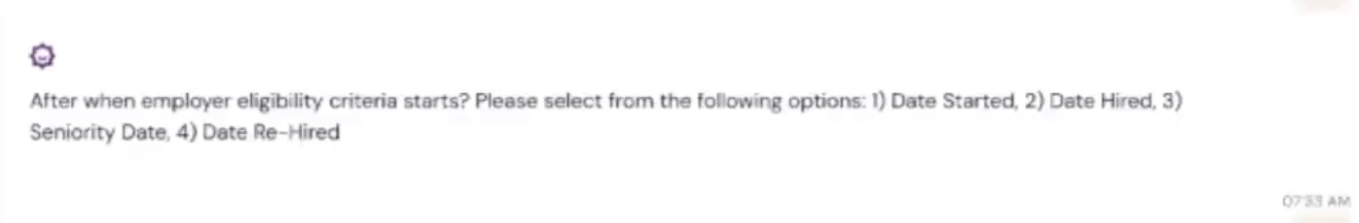
Sources
Principle | Essence (what it means) | Canonical sources
Clarity | Use plain language that matches the user’s mental model; avoid system jargon; make meanings obvious. | NN/g Heuristics: “match between system and the real world,” plain-language messages, and clear problem/solution guidance. (Nielsen Norman Group)
Brevity | Keep prompts short and actionable; rely on UI structure (choices, chips) instead of long prose. | Google Conversation Design emphasizes natural, concise prompts and scalable patterns for conversational turns. (Google for Developers)
Context Awareness (Memory) | Reuse what the system already knows; confirm scraped/derived values instead of re-asking; handle interruptions gracefully. | Microsoft Bot CUX on carrying context, disambiguation, and interruption handling. (Microsoft Learn)
Order & Flow (Turn-taking) | Ask in logical sequence (prerequisites → details); guide users through sections with smooth transitions. | Microsoft Learn on conversation flow design and navigation; Google conversation flow guidance. (Microsoft Learn)
Confirmation & Feedback | Acknowledge what was saved; make system status visible; offer quick edits. | NN/g Heuristics on visibility of system status & feedback; Microsoft UX guidance on progressive confirmations. (Nielsen Norman Group)
Error Recovery | Provide “help/skip/example”; prevent errors where possible; recover with friendly, specific guidance. | NN/g: recognize/diagnose/recover from errors; Microsoft Bot CUX error-handling patterns. (Nielsen Norman Group)
Consistency | Keep wording, formats, and option types uniform; use the same labels across prompts and summaries. | NN/g consistency/standards heuristic. (Nielsen Norman Group)
Proactive Guidance | Offer tips, defaults, and “good path” suggestions; surface consequences briefly. | Alexa Design Guide best practices; Microsoft Learn on designing engaging, guided UX. (Developer Portal Master)
Accessibility & Inclusivity | Design for everyone: inclusive language, predictable patterns, clear choices; avoid reliance on recall. | Microsoft Bot CUX includes ethics & inclusive design guidance for bots. (Microsoft Learn)
Empathy & Tone | Sound helpful, human, and confident—especially around complex or compliance topics. | Erika Hall, Conversational Design (tone and language for human-centered systems); Cathy Pearl, Designing Voice User Interfaces (VUI prompt craft & confirmations). (A Book Apart)

